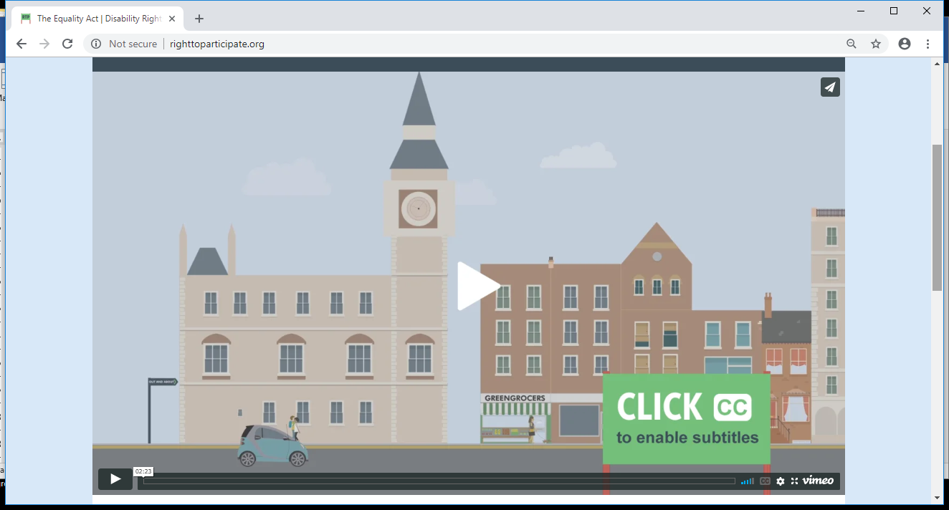

Descriptive transcript for Right to Participate animation

This Disability Rights UK film is an animated introduction to the Equality Act. It lasts just under two and a half minutes. The film opens along a busy high street showing cars, rows of shops and people walking and cycling by. The animation continues to pan down the street.

“We all have a human right to fair and equal treatment. And here in Britain, we can be proud that we have laws to promote equality in places like schools, workplaces, hospitals and shops.”

A judge appears in the window of a court building and a woman walks down the road and goes into her local library.

“The Equality Act was passed in 2010, bringing together lots of separate laws on areas like sex discrimination, race relations and disability discrimination. Disabled people battled for many years to achieve these rights, campaigning against negative attitudes and many physical and social barriers.”

The woman pulls a book about the Equality Act down from a shelf and opens it up to show an animated page of disability campaigners. They are waving placards showing the words ‘Social Model’, ‘Inclusion’ and ‘Access’.

The film continues to pan down the street until it stops outside a café. It zooms in on a man using his laptop to search for information on discrimination. He initially looks bewildered by the overwhelming amount of information online – but then the Right to Participate website appears.

“The Equality Act can help us all at some point in our lives, in ways you might not even realise. You can use it to challenge unfairness and bring about change. Our Right to Participate website aims to give you enough understanding to take action early, when a problem first arises. For example, if you’re a student, you can ask your college to provide support to help you succeed with your studies.”

A bus pulls up outside a college and a blurred sheet entitled ‘Help with dyslexia’ comes into clear focus when a yellow overlay is placed on top.

“If you’re off sick because of a long-term health condition, you have the right not to be penalised when you go back to work. With some illnesses, such as cancer, you’re covered by the Equality Act from when you first have it.”

A man leaves work. We see him looking unwell. He returns to his office several months later. The passage of time is shown by diary pages flicking forwards. The following support arrangements and reasonable adjustments are shown in his diary in the first week back; ‘Access to work meeting’, ‘Rest day’ and ‘Refresher training’.

“If you can’t get into a shop because the doors are too narrow for your wheelchair, or you can’t get up the steps, the building owner may have to make changes.”

A ramp rises up to make entrance to a shop accessible.

“And if you have a guide dog, it’s the Equality Act that protects your right to book a minicab which will carry you and your dog.”

A woman and her guide dog are shown travelling by taxi. They get out in front of a cinema where a film called ‘Right to Participate’ is showing. A variety of different disabled people go into the cinema and sit down together in front of the screen. A BSL interpreter signs ‘Right to Participate’ as the film begins.

“Disability rights are about these day-to-day freedoms, to live and to participate in society, which we all share and want to enjoy. You can also visit our forum to share experiences of using the Equality Act, any barriers you've faced, and to find support. Disability Rights – the Right to Participate.”

