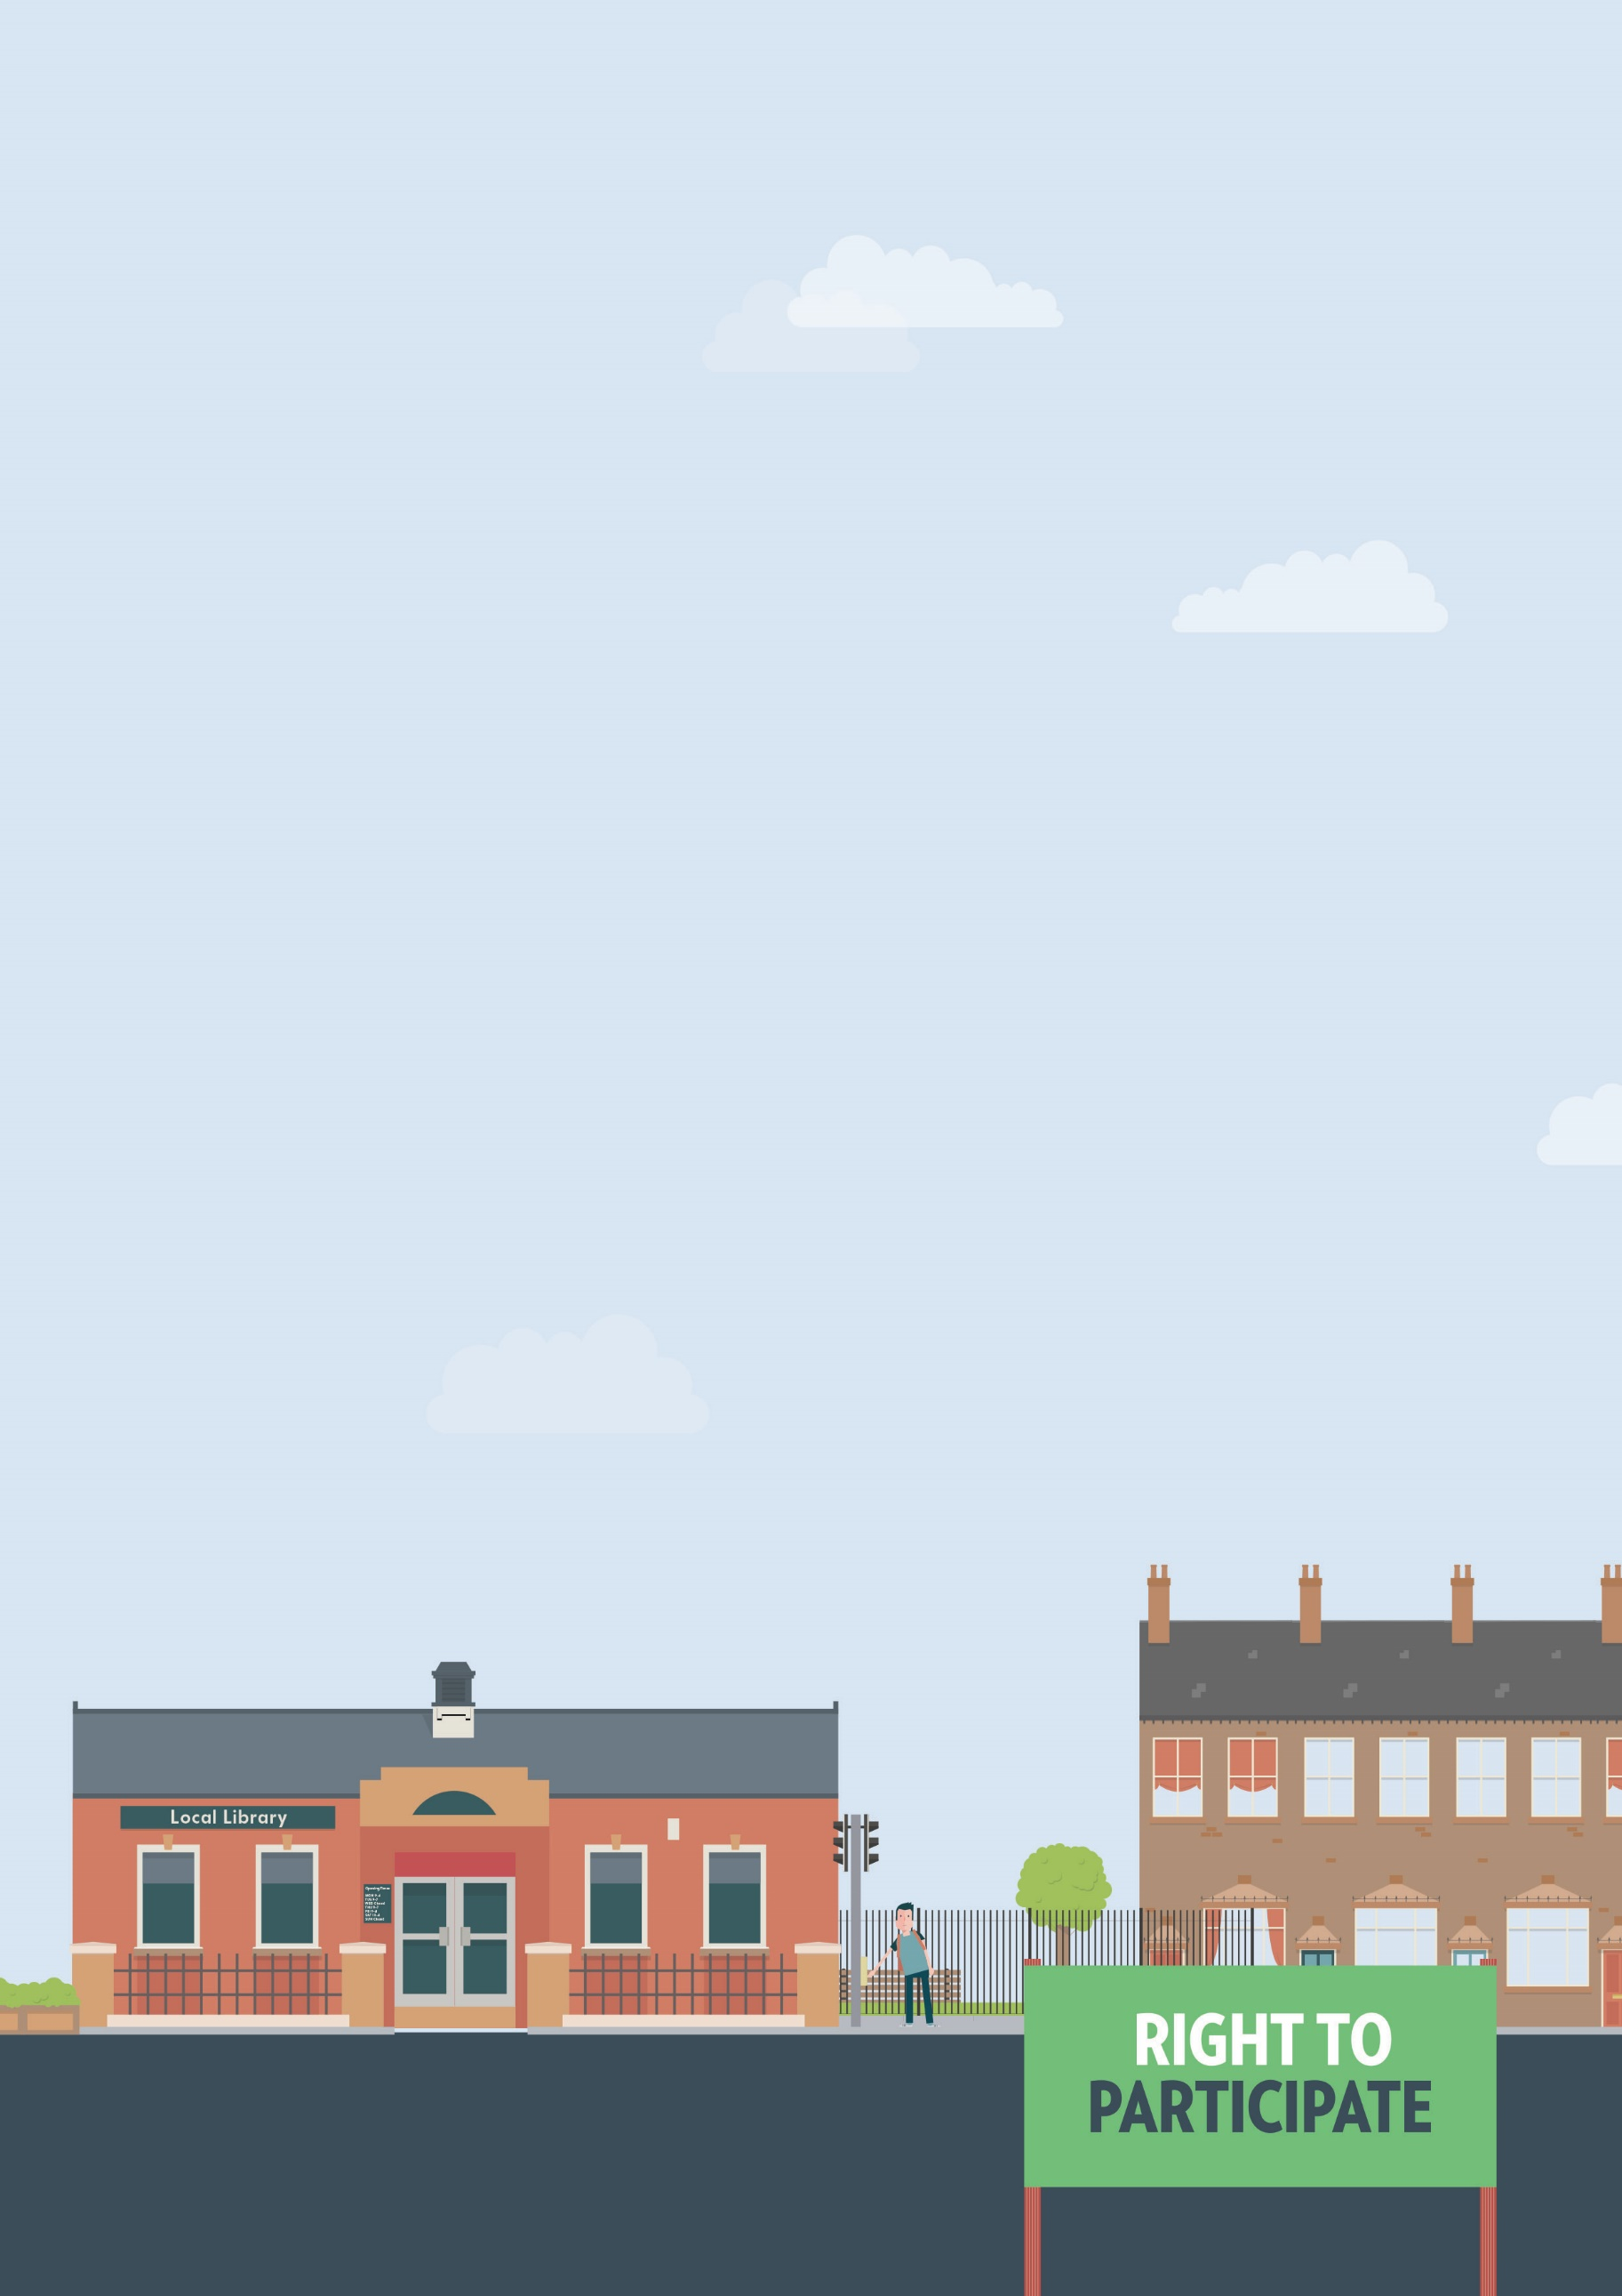
Current student
Harassment
Education

Useful knowledge
Under the Equality Act 2010, all colleges and universities are legally responsible for acts of harassment carried out by their staff unless they can show they took all reasonable steps to stop it. Harassment happens if the unwanted actions of your college or university violate your dignity or create an intimidating, hostile, degrading, humiliating or offensive environment for you. Unwanted actions may include spoken or written words or abuse, imagery, graffiti, physical gestures, facial expression, jokes and pranks. The action may not be directed at you but may nevertheless create that environment for you.
If you’ve been attacked you should report it to the Police immediately.
Useful knowledge
- Effective communication
- Negotiation skills
- Writing clearly
- Decision making
- Record-keeping
- Being able to keep track
Ways to assert your legal rights
- If possible, speak to or write an email or letter to the person concerned Tell them how their behaviour is making you feel and ask them to stop. Explaining this to them may be enough for them to rethink their actions. Do this at the earliest opportunity to stop the behaviour from getting worse. Keep a record of the incidents with times and dates so you can give examples of the offensive behaviour.
- If you feel unable to approach the person concerned, or the harassment persists, you should speak to your Personal Tutor, Student Union Advisors or the staff member responsible for disability. This person is usually called the learning support adviser, inclusive learning coordinator or disability adviser. They can help you work out how best to respond to the harassment and help you understand the procedures to follow. They may also be able to approach the staff member concerned to help prevent further harassment.
You should continue to record in writing any further incidents and keep the details of any witnesses.
- If you’ve exhausted the informal options and still aren’t happy with the outcome, or if the incidents are very serious and not possible to resolve yourself, you can make a formal complaint. You can usually find information about the internal complaints procedure from your student handbook or the college or university website. They must make the complaints procedure available to you in your preferred format.
You should include the name of the person harassing you and provide full details of what has happened, including dates and times, how it is affecting you, the names of any witness and copies of evidence.
Download template complaint letter about discrimination
by harassment.
- If you’re in higher education and have exhausted the complaints procedure and are unhappy with the outcome you can take your complaint to the Office of the Independent Adjudicator (OIA). At the end of the complaints process you will be issued with a Completion of Procedures letter. You have 12 months from the date on this letter to submit a complaint to the OIA.
In considering issues related to discrimination the OIA does not act as a court. It does not investigate or make legal findings in the same manner as a court. However, the OIA can refer to the law and guidance on discrimination to form an opinion as to good practice and to decide whether the university has acted fairly.
- If you’ve exhausted the complaints process and the education provider has failed to make a reasonable adjustment to the application process you may be able to take legal action. Taking court action can be a long, stressful and sometimes a very expensive process.
There are strict time limits for taking legal action under the Equality Act. You will have six months minus one day from the date of discrimination to make your claim in the County Court. Where a complaint has been made to the OIA, there is an extension available under the Equality Act s.118(2) and (3) – so that the claim must be within nine months rather than six.
The court can also consider claims outside the time limit if it considers it ‘just and equitable’ to do so.
You should take legal advice should you wish to pursue this through the legal route.
You can get more help from
The Equality Advisory & Support
Service (EASS) runs a free helpline assisting individuals with equality and human rights issues across England, Scotland and Wales.
Telephone
Text phone
Email
0808 800 0082
0808 800 0084
through websites form

Disability Rights UK student helpline
Telephone
Email
0330 995 0414
students@disabilityrightsuk.org

Disability Rights UK free factsheets on
Understanding the Equality Act and
Making a complaint
Disability Rights UK Into Higher Education guide

The Office of the Independent Adjudicator (OIA) is an independent body which investigates student complaints against higher education providers.
Telephone casework support team
Email
0118 959 9813
through website form

